Reading/Language Classroom News 032519
Mrs. R. Balsamo
Reading  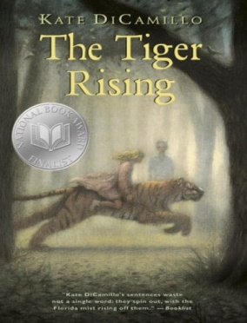 | ****ALL STUDENTS WILL NEED ONE EMPTY LARGE CEREAL BOX AND TWO EMPTY PAPER TOWEL ROLLS BY WEDNESDAY, MARCH 27th.****  THE TIGER RISING by Kate DiCamillo Chapters 5-10 Vocabulary/comprehension  Vocabulary and questions will be in student notebooks for review purposes as information/chapters are completed.  Wordly Wise Vocabulary Lesson 11 Words: average, border, cocoon, flutter, moisture, moist, nectar, process, span  Excellent home sites: Wordly Wise words Lesson 11  http://www.wordlywise3000.com/word_lists/?book=03&lesson=111 (listen to words by clicking on Lesson 11 in lower left corner)  https://quizlet.com/31344891/wordly-wise-3000-book-3-lesson-11-flash-cards/ (to review and practice words after learning Lesson 11)  Lesson 16 Phonics: Word Sounds – air, ear, are  *REMINDER: READING HOMEWORK IS TO COMPLETE 2 KIDBIZ SELECTIONS WEEKLY – STORY AND QUESTIONS.
Language | Lesson 16: Adjectives that tell what kind Spiral Review: More Plural Nouns  Lesson 17: Adjectives and Articles/Spiral Review: Writing Proper Nouns
Spelling | Lesson 17 /j/ and /s/ Words: age, space, change, jawbone, jacket, giant, pencil, circle, once, large, dance, jeans, bounce, huge, nice, place, excited, gigantic  Spelling City website: www.spellingcity.com/rbalsamo/
Writing | WRITNG BENCHMARK TEST  Information Writing: a type of nonfiction writing that conveys  information about something, which means it is factual. An example is the biography project currently being completed.
Assessments | Spelling: Lesson 17 Test 3/29  Language: Lesson 16 Test 3/26; Lesson 17 Test 4/2  Reading: The Tiger Rising Chapters 1-4 Vocabulary/Comprehension Test 3/27  Phonics: Lesson 16 air, ear, are TEST 3/27
Notes and Reminders | *Test folders are red will be sent home on Wednesdays. Parents should review work with students, initial ALL tests, and return to school in their test folder by Friday.  *Our class is a NUT FREE ZONE! Please avoid sending nuts for any snack.  *Thanks to all parents for donating to the Leukemia and Lymphoma Society!  *Crawfish Boil Art can be purchased in advance of the Crawfish Boil for $10 – artwork will be sent home by March 28th  *LUSHER CRAWFISH BOIL – MARCH 30th  *Student of the Week for MARCH 25-29: Isabella Costa  *My email address is Rhonda_balsamo@lusherschool.org  *Third grade website is: http://thirdgradelusher.weebly.com/  *Our class website is: http://msbalsamothirdgrade.weebly.com/  *OUR CLASS PICTURE IS SCHEDULED FOR WEDNESDAY, MARCH 27th.

