Reading/Language Classroom News 040119
Mrs. R. Balsamo
Reading  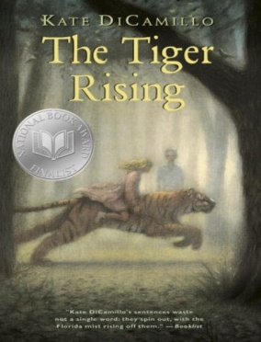 | THE TIGER RISING by Kate DiCamillo Chapters 11-16 Vocabulary/comprehension  Vocabulary and questions will be in student notebooks for review purposes as information/chapters are completed.  Wordly Wise Vocabulary Lesson 11 Words: average, border, cocoon, flutter, moisture, moist, nectar, process, span  Excellent home sites: Wordly Wise words Lesson 11  http://www.wordlywise3000.com/word_lists/?book=03&lesson=111 (listen to words by clicking on Lesson 11 in lower left corner)  https://quizlet.com/31344891/wordly-wise-3000-book-3-lesson-11-flash-cards/ (to review and practice words after learning Lesson 11)  Lesson 17: Words with /j/ and /s/ sounds  PROJECT BASED LEARNING PROJECT: Biography (Informational Writing): Research completed on Introduction (Birth/Death/Importance) /Character Traits (with supporting details) /Childhood /Adulthood – Final draft completed on these sections (REMAINING RESEARCH: Current Day/ Influence)  *REMINDER: READING HOMEWORK IS TO COMPLETE 2 KIDBIZ SELECTIONS WEEKLY – STORY AND QUESTIONS.
Language | Lesson 17: Adjectives and Articles/Spiral Review: Writing Proper Nouns  Lesson 18: The Special Verb BE
Spelling | Lesson 18 /k/ and /kw/ Sounds – Words: shark, check, queen, circus, flake, crack, second, squeeze, quart, squeak, quick, coldest, Africa, Mexico, black, thank, correct, question  Spelling City website: www.spellingcity.com/rbalsamo/
Writing | Information Writing: a type of nonfiction writing that conveys  information about something, which means it is factual. An example is the biography project currently being completed in Reading class as our Project Based Learning Project.
Assessments | Spelling: Lesson 18 Test 4/5  Language: Lesson 17 Test 4/2  Reading: The Tiger Rising Chapters 1-8 Vocabulary/Comprehension Test 4/3  Wordly Wise: Lesson 11 TEST 4/3
Notes and Reminders | *Test folders are red will be sent home on Wednesdays. Parents should review work with students, initial ALL tests, and return to school in their test folder by Friday.  *Our class is a NUT FREE ZONE! Please avoid sending nuts for any snack.  *Thanks to parents that offered to help with painting for our Project Based Learning Project! You are the BEST!  *Class Pizza Party – Friday, April 5th (Water needed – please!)  *Early Dismissal –Wednesday, April 3rd (2:00 dismissal for students)  *Assembly for third graders – Wednesday, April 3rd – George Rodrigue presentation  *Student of the Week for April 8-12: Lauren Breaux  *My email address is Rhonda_balsamo@lusherschool.org  *Third grade website is: http://thirdgradelusher.weebly.com/  *Our class website is: http://msbalsamothirdgrade.weebly.com/

