Reading Classroom News 040119
Mrs. R. Balsamo
Reading:  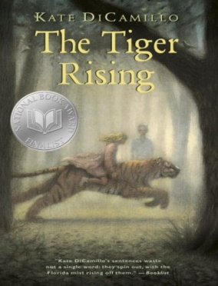 | THE TIGER RISING by Kate DiCamillo Chapters 11-16 Vocabulary/comprehension  Vocabulary and questions will be in student notebooks for review purposes as information/chapters are completed.  Wordly Wise Vocabulary Lesson 11 Words: average, border, cocoon, flutter, moisture, moist, nectar, process, span  Excellent home sites: Wordly Wise words Lesson 11  http://www.wordlywise3000.com/word_lists/?book=03&lesson=111 (listen to words by clicking on Lesson 11 in lower left corner)  https://quizlet.com/31344891/wordly-wise-3000-book-3-lesson-11-flash-cards/ (to review and practice words after learning Lesson 11)  Lesson 17: Words with /j/ and /s/ sounds  PROJECT BASED LEARNING PROJECT: Biography (Informational Writing): Research completed on Introduction (Birth/Death/Importance) /Character Traits (with supporting details) /Childhood /Adulthood – Final draft completed on these sections (REMAINING RESEARCH: Current Day/ Influence)  *REMINDER: READING HOMEWORK IS TO COMPLETE 2 KIDBIZ SELECTIONS WEEKLY – STORY AND QUESTIONS.
Assessments | Reading: The Tiger Rising – Chapters 1-8 Vocabulary/Comprehension TEST 4/3/19  Wordly Wise: Lesson 11 TEST 4/3/19
Notes and Reminders | *Test folders are red will be sent home on Wednesdays. Parents should review work with students, initial ALL tests, and return to school in their test folder by Friday.  *Our class is a NUT FREE ZONE! Please avoid sending nuts for any snack.  *THANKS TO PARENTS OFFERING TO PAINT FOR OUR PROJECT – YOU ARE GREATLY APPRECIATED!  *My email address is Rhonda_balsamo@lusherschool.org  *Third grade website is: http://thirdgradelusher.weebly.com/  *Our class website is: http://msbalsamothirdgrade.weebly.com/

