Reading/Language Classroom News 040819
Mrs. R. Balsamo
Reading  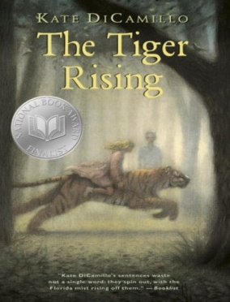 | THE TIGER RISING by Kate DiCamillo Chapters 17-24 Vocabulary/comprehension  Vocabulary and questions will be in student notebooks for review purposes as information/chapters are completed.  Phonics: Lesson 17: Words with /j/ and /s/ sounds; Lesson 18: Words with /k/ and /kw/  PROJECT BASED LEARNING PROJECT: Biography (Informational Writing): Research completed on Introduction (Birth/Death/Importance) /Character Traits (with supporting details) /Childhood /Adulthood – Final draft completed on these sections (REMAINING RESEARCH: Current Day/ Influence)- Report completed by 4/18 so construction of project after the break – STUDENTS NEED THEIR BOOK DAILY BUT ARE WELCOME TO LEAVE IN SCHOOL.  *REMINDER: READING HOMEWORK IS TO COMPLETE 2 KIDBIZ SELECTIONS WEEKLY – STORY AND QUESTIONS.
Language | Lesson 18: The Special Verb BE Spiral Review: Subject-Verb Agreement
Spelling | Lesson 19 Vowel Sounds in SPOON and WOOD Words: mood, wooden, drew, smooth, blue, balloon, true, crooked, chew, tooth, hooves, cool, food, pooch, blew, foot, loose, jewel  Spelling City website: www.spellingcity.com/rbalsamo/
Writing | Information Writing: a type of nonfiction writing that conveys  information about something, which means it is factual. An example is the biography project currently being completed in Reading class as our Project Based Learning Project.
Assessments | Spelling: Lesson 19 Test 4/12  Language: Lesson 18 Test 4/9  Reading: The Tiger Rising – Chapters 1-16 Vocabulary/Comprehension TEST 4/17  Phonics: Lesson 17 Words with /j/ and /s/ TEST 4/10; Lesson 18 Words with /k/ and /kw/ TEST 4/17
Notes and Reminders | *Test folders are red will be sent home on Wednesdays. Parents should review work with students, initial ALL tests, and return to school in their test folder by Friday.  *Our class is a NUT FREE ZONE! Please avoid sending nuts for any snack.  *Spring Break: April 19-26 School resumes Monday, April 29th  *State Testing for third grade: April 30 – May 3 (Attendance and arrival on time is EXTREMELY important!)  *Arts Happening: May 9th  *Student of the Week for April 8-12: Lauren Breaux  *Student of the Week for April 15-18: Gabriel Arata  *My email address is Rhonda_balsamo@lusherschool.org  *Third grade website is: http://thirdgradelusher.weebly.com/  *Our class website is: http://msbalsamothirdgrade.weebly.com/

