Reading Classroom News 040819
Mrs. R. Balsamo
Reading:  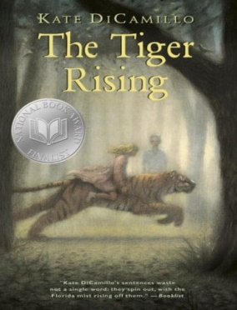 | THE TIGER RISING by Kate DiCamillo Chapters 17-24 Vocabulary/comprehension  Vocabulary and questions will be in student notebooks for review purposes as information/chapters are completed. Reading will be completed on this book break Spring Break.  Phonics: Lesson 17: Words with /j/ and /s/ sounds; Lesson 18: Words with /k/ and /kw/  PROJECT BASED LEARNING PROJECT: Biography (Informational Writing): Research completed on Introduction (Birth/Death/Importance) /Character Traits (with supporting details) /Childhood /Adulthood – Final draft completed on these sections (REMAINING RESEARCH: Current Day/ Influence)- Report completed by 4/18 so construction of project after the break – STUDENTS NEED THEIR BOOK DAILY BUT ARE WELCOME TO LEAVE IN SCHOOL.  *REMINDER: READING HOMEWORK IS TO COMPLETE 2 KIDBIZ SELECTIONS WEEKLY – STORY AND QUESTIONS.
Assessments | Reading: The Tiger Rising – Chapters 1-16 Vocabulary/Comprehension TEST 4/17  Phonics: Lesson 17 Words with /j/ and /s/ TEST 4/10; Lesson 18 Words with /k/ and /kw/ TEST 4/17
Notes and Reminders | *Test folders are red will be sent home on Wednesdays. Parents should review work with students, initial ALL tests, and return to school in their test folder by Friday.  *Our class is a NUT FREE ZONE! Please avoid sending nuts for any snack.  *Spring Break: April 19-26 School resumes Monday, April 29th  *State Testing for third grade: April 30 – May 3 (Attendance and arrival on time is EXTREMELY important!)  *My email address is Rhonda_balsamo@lusherschool.org  *Third grade website is: http://thirdgradelusher.weebly.com/  *Our class website is: http://msbalsamothirdgrade.weebly.com/

