…SPRING BREAK
Reading/Language Classroom News 0401519
Mrs. R. Balsamo
Reading  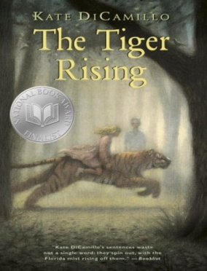 | THE TIGER RISING by Kate DiCamillo Chapters 24-30 Vocabulary/comprehension  Vocabulary and questions will be in student notebooks for review purposes as information/chapters are completed. Book completed!  Phonics: Lesson 18: Words with /k/ and /kw/  PROJECT BASED LEARNING PROJECT: Biography (Informational Writing): Research completed on Introduction (Birth/Death/Importance) /Character Traits (with supporting details) /Childhood /Adulthood – Final draft completed on these sections (REMAINING RESEARCH: Current Day/ Influence)- Report completed by 4/18 so construction of project after the break – STUDENTS NEED THEIR BOOK DAILY BUT ARE WELCOME TO LEAVE IN SCHOOL.  Autobiography (Information Writing): Part 2 of project begins – Cover design/ Introduction of Appearance/ My Family and Friends/ Life at School/ Life at Home  After the break we will work on the final sections: My Future Plans/ How Will I Change History – Report completed by 5/9 so that construction of project can take place before parent presentations on 5/13 and 5/14 (PLEASE COME!)  Invitations will be sent out this week for presentations!  *REMINDER: READING HOMEWORK IS TO COMPLETE 2 KIDBIZ SELECTIONS WEEKLY – STORY AND QUESTIONS.
Language | Lesson 19: Irregular Verbs; spiral review: Subject-Verb Agreement
Spelling | Lessons completed for this year - NONE
Writing | Information Writing: a type of nonfiction writing that conveys  information about something, which means it is factual. An example is the biography project/autobiography currently being completed in Reading class as our Project Based Learning Project.
Assessments | Spelling: NONE completed for the year  Language: Lesson 19 Test 4/13  Reading: The Tiger Rising – Chapters 1-16 Vocabulary/Comprehension TEST 4/17; Chapters 1-30 TEST 5/8  Phonics: Lesson 18 Words with /k/ and /kw/ TEST 4/17; Lesson 19 Vowel Sounds in spoon and wood TEST 5/8  Wordly Wise: Lesson 12 TEST 5/15 (FINAL TEST FOR THE YEAR!)  During the week of May 6-10 students will complete the END OF THE YEAR LEVEL SET TEST FOR KIDBIZ!
Notes and Reminders | *Test folders are red will be sent home on Wednesdays. Parents should review work with students, initial ALL tests, and return to school in their test folder by Friday.  *Our class is a NUT FREE ZONE! Please avoid sending nuts for any snack.  *Spring Break: April 19-26 School resumes Monday, April 29th  *State Testing for third grade: April 30 – May 3 (Attendance and arrival on time is EXTREMELY important!)  *Arts Happening: May 9th  *Student of the Week for April 15-18: Gabriel Arata  *Student of the Week for May 13-17: Aiden Ahmed  Class ice-cream party on 4/18!  *My email address is Rhonda_balsamo@lusherschool.org  *Third grade website is: http://thirdgradelusher.weebly.com/  *Our class website is: http://msbalsamothirdgrade.weebly.com/

