HAPPY MOTHER’S DAY!
Homeroom Classroom News 051319
Mrs. R. Balsamo
Reading:  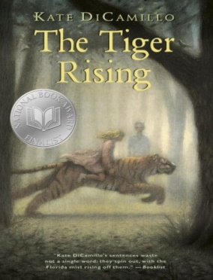 | THE TIGER RISING by Kate DiCamillo Activities involving the characters, setting, and plot – and ART!  PROJECT BASED LEARNING PROJECT: Presentations of Biography and Autobiography projects  First period (Balsamo) and Third period (Dayeh): Monday, May 13th  (First Period 9:30-10:00/Third Period 12:45-1:15)  Second period (Tyler) and Fourth period (Louviere): Tuesday, May 14th  Tuesday, May 14th (Second Period 10:30-11:00/Fourth Period 2:45-3:15)  Parents will take projects home after presentations!  PLEASE COME!!!!!!  *REMINDER: READING HOMEWORK IS TO COMPLETE 2 KIDBIZ SELECTIONS WEEKLY – STORY AND QUESTIONS.
Writing | We will be working on our third grades memories in writing!
Assessments | Wordly Wise: Lesson 12 TEST 5/16 (changed due to our field trip to the Botanical Gardens) (FINAL TEST FOR THE YEAR!)  During the week of May 7-10 students will complete the END OF THE YEAR LEVEL SET TEST FOR KIDBIZ!
Notes and Reminders | *Test folders are red will be sent home on Wednesdays. Parents should review work with students, initial ALL tests, and return to school in their test folder by Friday.  *BIOGRAPHY/AUTOBIOGRAPHY Presentations:  Monday, May 13th (First Period 9:30-10:00/Third Period 12:45-1:15)  Tuesday, May 14th (Second Period 10:30-11:00/Fourth Period 2:45-3:15)  *Botanical Gardens field trip- Wednesday, May 15th Students will need a lunch/drink and comfortable shoes. (Fingers crossed for NO rain!)  *Student of the Week for May 13-17: Aiden Ahmed  *JCC swimming field trip: Tuesday, May 21st permission slips and fees due!  *Our class is a NUT FREE ZONE! Please avoid sending nuts for any snack.  *My email address is Rhonda_balsamo@lusherschool.org  *Third grade website is: http://thirdgradelusher.weebly.com/  *Our class website is: http://msbalsamothirdgrade.weebly.com/

