Math Topic 12 Study Guide – Time

Target: I can tell time to the half hour and quarter hour.

- What are two other ways to write 9:45? _________________________________________________________

_________________________________________________________

- What are two other ways to write 11:15? _______________________________________________________

_______________________________________________________

Write the time shown on the clocks below two different ways.

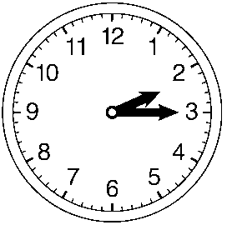
_____________________________________________________

_____________________________________________________

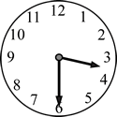
- ______________________________________________________

______________________________________________________

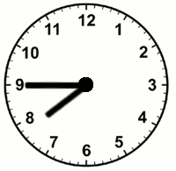
- ______________________________________________________

______________________________________________________

Target: I can tell time to the nearest minute.
Write the time shown on the clocks below two different ways.
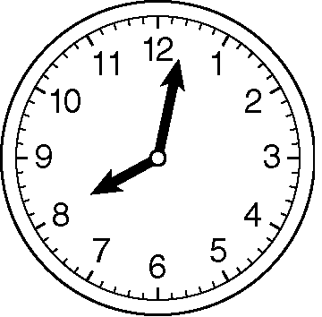
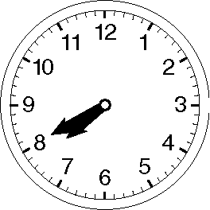
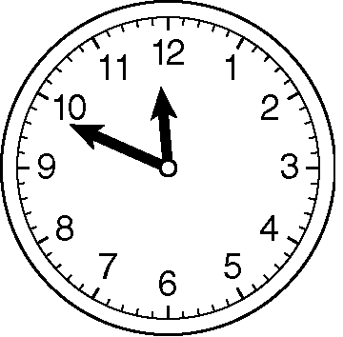
- 7. 8.

____________________ ______________________ ________________________

____________________ ______________________ ________________________

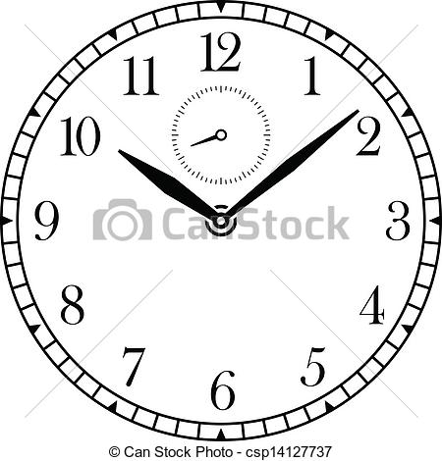
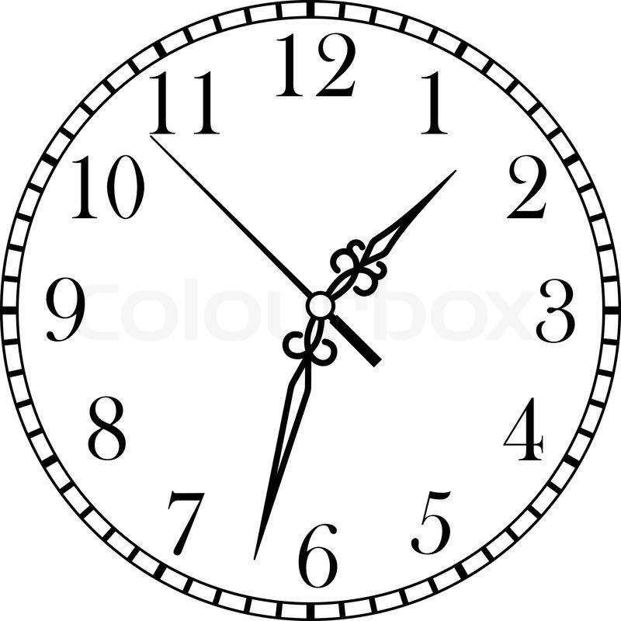
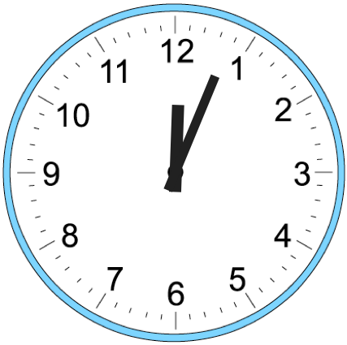
- 10. 11.

___________________ _____________________ _______________________

___________________ _____________________ _______________________

Target: I can tell how much time has elapsed.

- Marco went to the aquarium with his family. How long was Marco’s family gone?

This clock shows This clock show the
the time they left. time they returned.
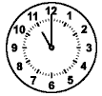
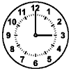

_______________________________________

- Rachel’s family started playing a game at 6:30p.m. and finished playing at 7:15p.m. How long did Rachel’s family play the game?

- Sam began his piano lesson at 3:10p.m. and finished at 4:00p.m. How long did Sam’s piano lesson last?

- Robin started eating lunch at 12:40p.m. and finished eating at 1:15p.m. How long was Robin’s lunch?

Target: I can work backward to solve a problem.

- Maria needs to arrive at school at 8:00a.m. It takes her 10 minutes to walk to school, 10 minutes to eat breakfast, and 20 minutes to shower and get dressed. What time does Maria need to wake up?

- Logan’s family wants to arrive at the movie theater at 4:45p.m. It takes them 15 minutes to drive to the theater and 10 minutes to eat a snack. What time should Logan’s family start eating their snack?

- Travis arrived home at 5:20 P.M. To get there he stood at the bus stop for 15 minutes, rode the bus for 35 minutes, and then walked another 10 minutes to get home. What time did he start his trip home?

- Tamika finished her necklace at 11:25 A.M. She took 15 minutes to pick out beads for the necklace, 15 minutes to string the beads, and then 10 minutes to put the clasp on the necklace. What time did she start making her necklace?

