Math Topic 4 Study Guide – Meanings of Multiplication

Target: I can write multiplication number sentences and repeated addition number sentences for a given situation.

1. Write a repeated addition sentence that has the same value as 5 x 2.

2. Write a multiplication sentence for 6 + 6 + 6 + 6 + 6 = 30.

3. Write a repeated addition sentence that has the same value as 6 x 7.

4. Can you write 2 + 3 + 4 = 9 as a multiplication sentence? Explain why or why not.

Target: I can use an array to find the product of a multiplication problem.

5. For the 4th of July, Ron put flags in his yard as shown below. Write a multiplication sentence that could be used to find how many flags Ron put in his yard. Then find the product.

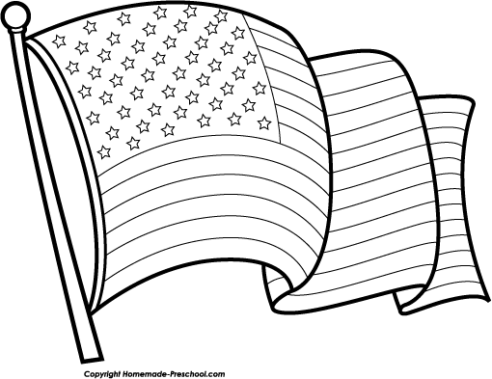

6. Mrs. Wilson is planting flowers in her garden. She plants 4 rows and puts 5 flowers in each row. Draw an array to show how many flowers Mrs. Wilson planted. Then find the product.

7. The Carroll family replaced the tiles on their kitchen floor. A 5 x 4 array of tiles fit the area. How many tiles did they use? Draw an array to find the product.

Target: I can use the Commutative Property of Multiplication to show that two numbers can be multiplied in any order and the product remains the same.

8. How can knowing that 3 x 8 = 24 help you find the answer to 8 x 3? Explain.

9. Write the number that makes the second number sentence true.

5 x 4 = 20 4 x 5 = _________

10. Draw an array to show each multiplication fact. Then find the products.
2 x 4 = 4 x 2 =

Target: I can write a multiplication story for a given multiplication fact.

11. Use the multiplication fact 3 x 6 to write a multiplication story, draw an array, and find the product.

12. Use the multiplication fact 6 x 2 to write a multiplication story, draw an array, and find the product.

Target: I can use words, pictures, and numbers to explain my understanding.

13. Ping pong balls are sold in cans that hold 4 tennis balls. How does the number of tennis balls change as the number of cans increases by 1?

Cans | 1 | 2 | 3 | 4
Tennis Balls | 4 | 8 | 12 | 16

14. Each row of a vegetable garden has 7 plants. How many plants are in 5 rows? Use a pattern to complete the table and solve. Then, explain your thinking.

Rows | 1 | 2 | 3 | 4 | 5
Plants | 7 | 14

