Math Topic 7 Study Guide – Meanings of Division

**Target: I can show division as sharing in equal groups.**

Draw a picture to show each division problem:

1. Tran has 20 crayons to share equally with 4 friends. How many crayons does he give to each friend?
2. Zach has 21 flowers to put equally in 3 vases. How many flowers will he put in each vase?

**Target: I can show division as repeated subtraction.**

1. Pam has 18 ice cubes to put in 6 glasses of water. She wants to put the same number of ice cubes in each glass. Use repeated subtraction to find how many ice cubes she should put in each glass.
2. Nora wants to find out how many groups of 7 are in 42. Show the steps she should follow if she uses repeated subtraction to find the answer.

**Target: I can find missing numbers in a multiplication table.**

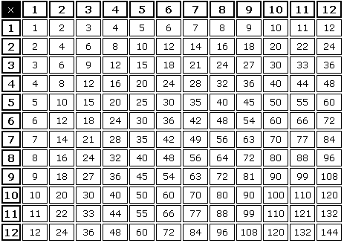Use the multiplication table to find the value for n that makes the equation true:



$21 ÷7 =n$

$40 ÷5 =n$

$48 ÷8 =n$

**Target: I can choose an appropriate equation to solve a problem.**

1. Martin has 12 pinecones. His bird feeder design uses 3 pinecones. Which equation shows how many bird feeders he can make?
$12+3=n$

$12÷3=n$

$12-3=n$

$12 × 3=n$

2. Ken has 6 rows of shells with 5 shells in each row. He wants to find the total number of shells he has. Which equation should he use?
$6+5=n$

$6÷5=n$

$6-5=n$

$6 × 5=n$

3. Katie buys 24 black marbles and 4 white marbles. Which equation shows how many marbles she bought altogether?

$24+4=n$

$24÷4=n$

$24-4=n$

$24 × 4=n$

**Target: I can write a division story for a division problem.**

1. Write a division story that could be solved with $35÷7=n$. Then, draw a picture and find the answer.

________________________________________________________________________________________________________________________________________________________________________________________________________________

________________________________________________________________________________________________________

Picture: Answer: _________________________

**Target: I can use objects and draw a picture to help me solve a problem.**



1. Naomi spilled some ink on her paper. The ink covered part of her picture of a tiled floor. The entire floor was shaped like a rectangle covered by 32 square tiles. How many tiles were in each row?

____________________________________