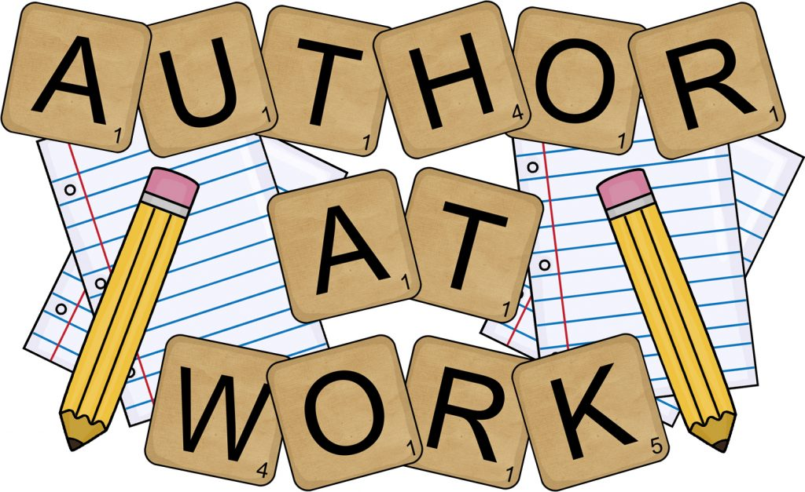
PROJECT BASED LEARNING PRESENTATION
TUESDAY, MAY 14, 2019 2:45-3:15
Ms. Balsamo’s Reading Fourth Period Class
Lusher Charter School: Third Grade

PLEASE COME!

