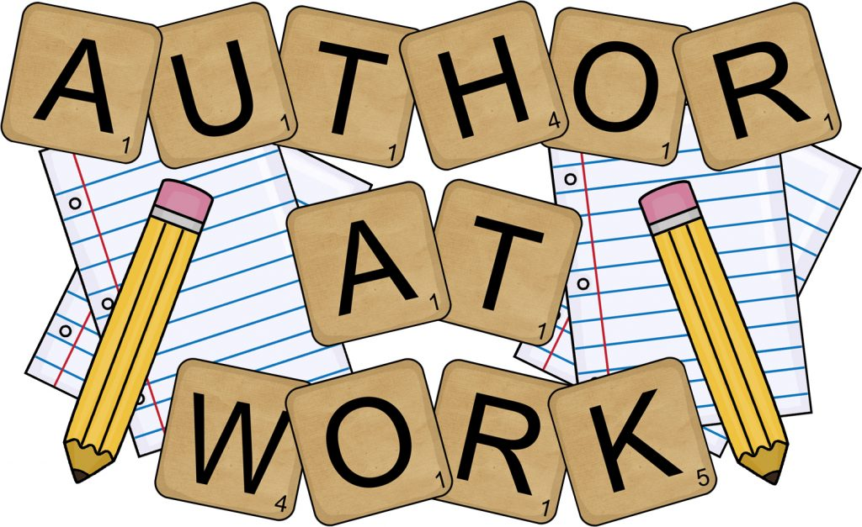
PROJECT BASED LEARNING PRESENTATION
TUESDAY, MAY 14, 2019 10:30-11:00
Ms. Balsamo’s Reading Second Period Class
Lusher Charter School: Third Grade

PLEASE COME!

