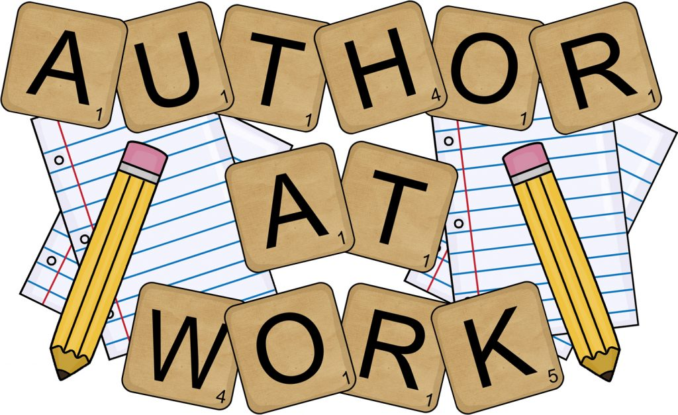
PROJECT BASED LEARNING PRESENTATION
MONDAY, MAY 13, 2019 12:45-1:15
Ms. Balsamo’s Reading Third Period Class
Lusher Charter School: Third Grade

PLEASE COME!

