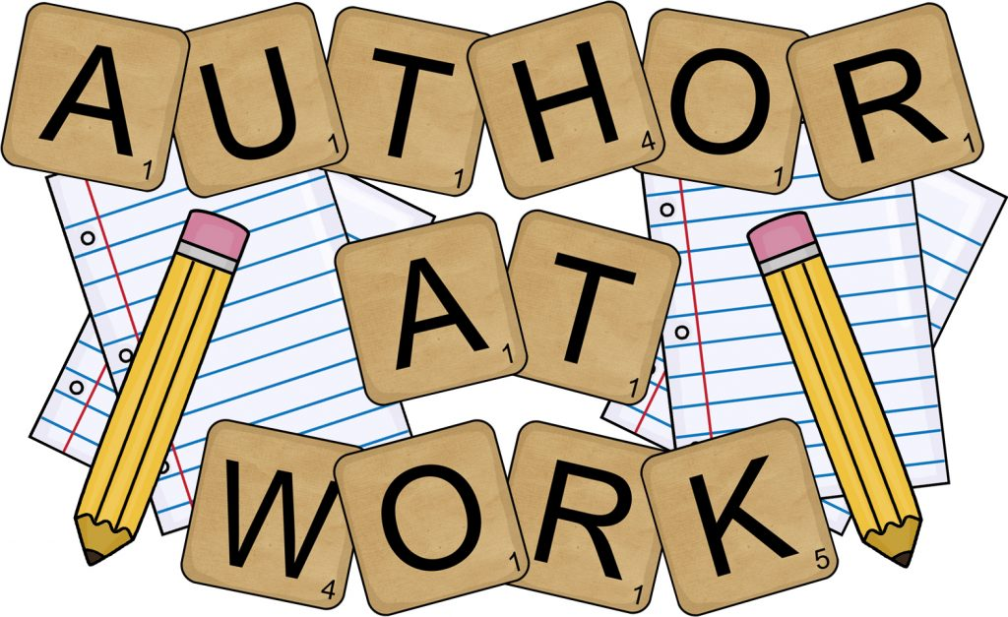
PROJECT BASED LEARNING PRESENTATION
MONDAY, MAY 13, 2019 9:30-10:00
Ms. Balsamo’s Reading First Period Class
Lusher Charter School: Third Grade

PLEASE COME!

