NAME: ___________________________ #

Study Guide: Unit 1 – Questions 1 & 2

Important Vocabulary

Observation: ________________________________________________________

___________________________________________________________________

Inference: __________________________________________________________

___________________________________________________________________

Organism: __________________________________________________________

___________________________________________________________________

Stigma: _____________________________________________________________

___________________________________________________________________

Stamen: ____________________________________________________________

___________________________________________________________________

Nectar: _____________________________________________________________

___________________________________________________________________

Pollinator: __________________________________________________________

___________________________________________________________________

Pollination: _________________________________________________________

___________________________________________________________________

Metamorphosis: _____________________________________________________

___________________________________________________________________

Reproduction: _______________________________________________________

___________________________________________________________________

Ovary: _____________________________________________________________

___________________________________________________________________

Label the three important parts of the flower that we learned about.
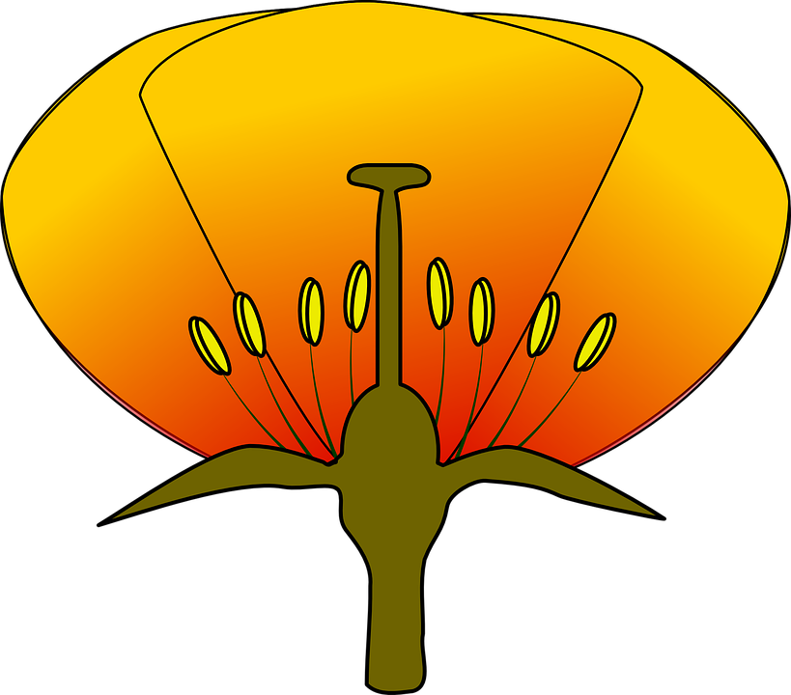

Be able to answer these questions using complete sentences, vocabulary words, and a lot of detail.

- Why do plants make flowers?

___________________________________________________________________

___________________________________________________________________

- Why do some plants make fruit?
___________________________________________________________________

___________________________________________________________________

- What are the 4 steps a flower goes through in order to become a fruit?
___________________________________________________________________

___________________________________________________________________

___________________________________________________________________

___________________________________________________________________

- Why are pollinators important?
___________________________________________________________________

___________________________________________________________________

- What are the 4 things every life cycle has in common?
___________________________________________________________________

___________________________________________________________________

- Why are pollinators attracted to flowers?
___________________________________________________________________

___________________________________________________________________

- Why is it important for plants to be pollinated?
___________________________________________________________________

___________________________________________________________________

- What is the difference between and observation and an inference?
___________________________________________________________________

___________________________________________________________________

