Study Guide: Unit 1 – Questions 1 & 2 ANSWER KEY

Important Vocabulary
Observation: a statement you make using one or more of your five senses
Inference: an educated guess you make based on your observations
Organism: any living thing
Stigma: the sticky center part of the flower that contains nectar
Stamen: the pollen dusters that surround the stigma
Pollinator: an organism that spreads pollen in order to get nectar from flowers
Nectar: sweet liquid in the center of the flower that attracts pollinators who drink it
Pollination: when a pollinator moves pollen from the stamen of one flower to the stigma of another flower
Metamorphosis: part of an organism’s life cycle where it changes from one body form to at least one more body form (only in insects and amphibians)
Reproduction: when organisms make more of themselves
Ovary: the part of the flower located at the bottom of the stigma that contains seeds and becomes a fruit after pollination
Label the three important parts of the flower that we learned about.
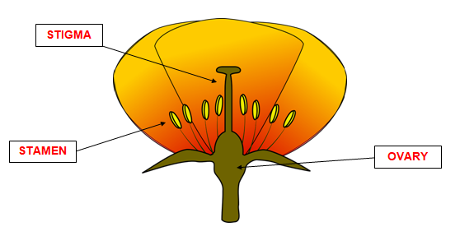

- Why do plants make flowers?
Plants make flowers so that they can attract pollinators who help them reproduce. Pollinators like flowers because of their sweet nectar and bright colored petals. Pollinators move pollen from the stamen of one flower to the stigma of another flower. This allows the flower to make seeds. When flowers make seeds they can reproduce and continue their life cycle.

- Why do some plants make fruit?
Plants grow fruit in order to reproduce. Fruit is a tasty container for the plant’s seeds. When animals eat the fruit and go somewhere else, they become like a car for the seeds. Later, the animal will poop out the seeds and the plant can grow again in a new location. This helps the plant spread it seeds and reproduce.

- What are the steps a flower goes through in order to become a fruit?
1. The flower is pollinated so now it can make seeds.
2. The petals shrivel up and fall off of the flower.
3. The ovary of the flower swells up. The seeds grow inside of the fruit (ovary).
4. When the fruit is ripe, it falls off of the plant. Its seeds are spread and the plant can reproduce.

- Why are pollinators important?
Pollinators are important because they help pollinate flowers. When a flower is pollinated, it can make seeds. Without pollination, most plants would not be able to reproduce. If plants could not reproduce, then we would not fruits or vegetables to eat. We would also not have enough oxygen to breathe.

- What are the 4 things every life cycle has in common?
The four things every life cycle has in common are birth, growth, reproduction, and death

- Why are pollinators attracted to flowers?
Pollinators are attracted to the bright colors of a flower’s petals and the sweet nectar inside of the flower. Pollinators drink the nectar for food.

- Why is it important for plants to be pollinated?
Some plants need to be pollinated in order to reproduce. Without pollination, many plants would not make seeds. Without seeds, the species of plant would die because its life cycle could not continue.

- What is the difference between an observation and an inference?
An observation is something you notice using your 5 senses. It is a fact and is not an opinion. An inference is something you think based on your observations and information you already know. You can use inferences to make a claim about the world around you.

